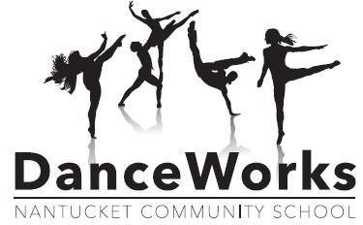

Payment Plan Contract

The purpose of this payment plan agreement is to design a schedule of installments towards fees due to Nantucket Community School for service provided.

Student Name : _____________________________________________

Billing Address:
NAME: ______________________________________
ADDRESS: ______________________________________
______________________________________
______________________________________

Mailing Address:
Same As Above _______
ADDRESS: ______________________________________
______________________________________
______________________________________

Program/Class(es) Enrolled In: Fee:
________________________________________________________ $_____________
________________________________________________________ $_____________
________________________________________________________ $_____________

Total Program Fees: $ _____________
Initial payment 50% of class fee (per class): $______________
Balance Remaining on Payment Plan: $ _____________

*****The remaining funds will be paid in February.
Payment Options (pick one)
____ Payments will be made by credit card which I authorize you to use.
Credit Card Information: (MasterCard and/or Visa *NO American Express) please circle one
Name as appears on card: _____________________________________
Number: ___________________________________________________
Expiration Date: _______________ CVV: _______________
Billing Address: ______________________________________________
______________________________________________
____ Payments will be made by cash or check.

Due Date | Amount Due
February 1st

TERMS AND CONDITIONS:
- All payment installments will be made on time understanding this means on or before the first of every month.
- If a check is returned for insufficient funds, there will be a fee of $25.00.
- Payment must be completed by the terms of the payment plan for participants to remain actively enrolled in the program, obtain dancers costume(s) and receive two free recital tickets.
- If payment is not received on time, the customer’s future enrollment in all NCS programs will be withheld.
- All outstanding balances with the Community School must be paid in full in advance to registering for new programs. Failure to do so will jeopardize attendance in Nantucket Public School events such as field trips, athletics and graduation.
- I certify that I have read and fully understand the conditions and terms of this agreement.
Signature: ________________________________________________ Date: _____________

